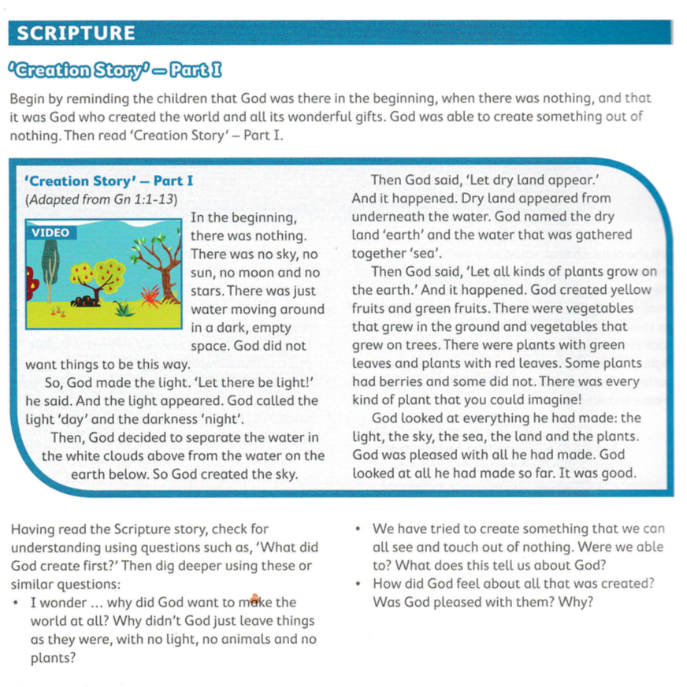

<https://vimeo.com/202723426>