Active Schools- Home Schooling challenge/exercises
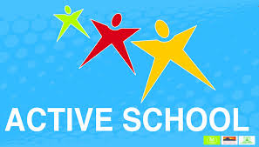

Monday | Tuesday | Wednesday | Thursday | Friday
Card Exercises | Animal Walks | Family run/walk | Name the Dance | Keepie uppie challenge
Wall Ball | Beat the Ball | Plank challenge | Press ups x10  Sit ups x10  Can you do more ? | Yoga challenge with Niamh #2
Copy Cat Exercises | Yoga challenge with Niamh #1 | Toilet Roll keepie uppies | Meditation | Rock Paper Scissors with parent or sibling
Videos for challenges

Monday
https://www.youtube.com/watch?v=6niUsVNkH-g Card challenge
https://www.youtube.com/watch?v=Jrf0idufmuk
Copy Cat challenge
Tuesday
https://www.youtube.com/watch?v=I8RSjQnXKeo Animal Walks
https://www.youtube.com/watch?v=VZIMtQKJW88
Thursday
https://www.youtube.com/watch?v=5mZGV34hMyI Name that Dance
https://www.youtube.com/watch?v=Bk_qU7l-fcU
Meditation
Friday
https://www.youtube.com/watch?v=Qk266YDKNs8 Rock Paper Scissors

