Dear you,

Happy St Patrick’s Day from everyone at EPIC The Irish Emigration Museum.

Around the world our heritage, our culture and our contribution to the world is being celebrated today. Many are, of course, doing it at home instead of at parades or parties. We are doing our best to keep safe and well and hope the same for you.

Irish healthcare workers, emergency responders and volunteers are making every effort to save lives worldwide. Their dedication, commitment and example are truly heroic and we applaud them. The community spirit that sees thousands of people checking on elderly neighbours, delivering groceries and medication or just offering to share conversation is the truest modern example of the Irish Meitheal we have seen.

This year the St Patrick’s celebrations may be very different and many of us will celebrate at home. Our creative colleagues have collected some great ways for you to mark the day.

Celebrate the memory of your ancestors and relatives who emigrated – add their details to our Museum and give them the recognition they deserve.

Make a mess and some fun memories with children by making EPIC green slime. Your youngsters will thank you.

Find your Irish roots emerging through our Family Tree research pack to download for free here.

Join in with St Patrick's Day Celebrations as iconic sites around the world join in the #GlobalGreening.

Watch world renowned Irish fiddle player Colm Mac Ion Iomaire performing an entire concert from his living room.

See Savage Beauty - Loch na Fuaiche, the Mountains of Connemara lit up green as part of the Galway 2020 celebrations.

Look at the pictures the Irish diaspora have shared with the Irish Times Abroad.

Locate an Irish community or service near you with the newest Global Irish Diaspora Directory.

Share your emigration story with us. We aim to record and preserve Ireland's migration stories for posterity. Add yours to have it saved in Europe's Leading Tourist Attraction.

Make green slime - download our free St Patrick's Day pack.

Download pack

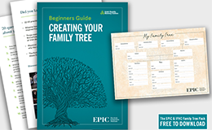

Start your Family Tree - download our free starter pack.

Find out more

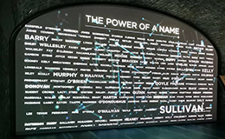

Add your family name to our 'Power of a Name' Emigrant Wall.

Add your family

Follow the #globalgreening hashtag to see iconic sights turned green.

Read more

When it is safe to travel again please do come visit us at EPIC and discover what Ireland has given to the world. You'll be very welcome.

Beannachtaí na Féile Pádraig Ort,

J Patrick Greene,
CEO and Museum Director.

