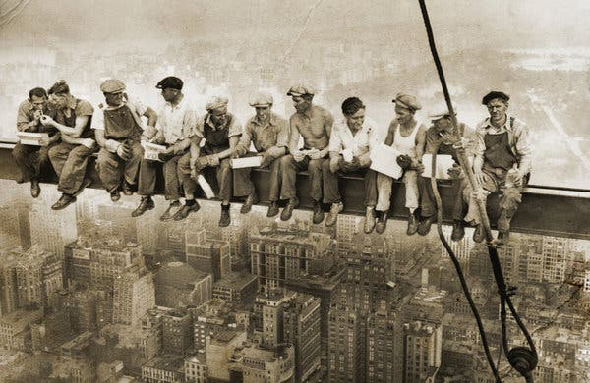
Lunch atop a Skyscraper

Look at this picture above and discuss with someone at home your answers to the following questions.
- Where do you think this picture was took? Why do you think this?
- How do you feel when you look at this picture? What are your thoughts?
- How do you think the men are feeling in this picture?
- Is this a recent picture?
- What different items can you see in this picture?
- Any other thoughts?

More info here: https://en.wikipedia.org/wiki/Lunch_atop_a_Skyscraper

