‘Music Smarts’ – How to Identify and Foster Musical Intelligence in Children
Music gives a soul to the universe, wings to the mind, flight to the imagination and life to everything – Plato
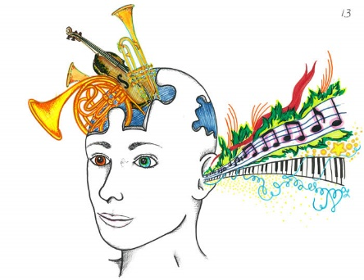
What is musical intelligence?
American psychologist Howard Gardner identified nine different types of intelligence that humans can possess. (See previous How Smart Are You? How Are You Smart?) One of these types of intelligence is musical intelligence. He describes the core features of musical intelligence as a sensitivity to pitch, melody, rhythm, timbre and the emotional aspects of sounds., Gardner claimed that musical intelligence was ‘parallel to linguistic (language intelligence)’. Indeed, music is often referred to as the ‘universal language’.
Most people associate musical intelligence with music talent. But believe it or not, they’re not the same thing! You don’t need to be an expert musician or a world class vocalist to have musical intelligence. In fact, this form of intelligence could be the secret strength you never knew you or your child had!
Musical intelligence, or ‘music smarts’, is essentially a form of auditory intelligence. It goes beyond music to incorporate all sounds, tones, and rhythms. The ability to discern pitch, rhythm, timbre, and tone enables us to recognize, create, reproduce, and reflect on music, as demonstrated by composers, conductors, musicians and vocalists. Certain individuals seem to have a superb natural ability to be creative with any rhyme, rhythm or sound. There are also cultures, particularly those without written language, where this intelligence is in evidence to a greater extent, possibly because the meter of a story makes it easier to remember and repeat for many generations, often word for word.
Most of us have at least some musical intellect; we can dance to a beat, or learn something using a jingle or a rhyme. We all know words to songs that we have not consciously made the effort to learn, which just goes to show how powerful music can be in enhancing the memory process. Musical intelligence does incorporate music, but it is wider. It encompasses rhythm and rhyme such as that found in poetry. Most children find it easy to learn rhythmically, which is why nursery rhymes and children’s songs are so popular. Indeed, some nursery rhymes have been passed down through generations for centuries. For example, children still sing ‘ring-a-ring-a roses’ from the 17th century.
Gardner suggested there could be a biological predisposition towards musical intelligence, citing Yehudi Menuhin as an example. Yehudi Menuhin, the 20th century American violinist and conductor, began attending San Francisco Orchestra concerts at age 3. The sound of Louis Persinger’s violin so entranced the child that he insisted on a violin for his birthday and Louis Persinger as his teacher. He got both! By the time he was ten years old, he was an international performer. Gardner posited that Menuhin’s rapid progress on the violin at such an early age suggests that he was biologically prepared in some way for a life in music. Keith Richards, lifelong musician, would seem to agree: Music is a language that doesn’t speak in particular words. It speaks in emotions, and if it’s in the bones, it’s in the bones.’ (Keith Richards)
Indeed, many accomplished musicians and performers describe music as something that was within them from an early age.
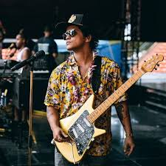
‘Ever since I was a kid, this was all I wanted to do. I’ve wanted to do music. I wanted to sing. It’s all I know’. (Bruno Mars)

Characteristics of Musical Intelligence in Children
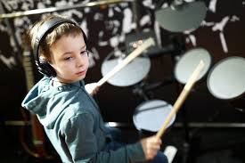
‘If you cannot teach me to fly, teach me to sing’ says J.M. Barrie in Peter Pan. As parents and teachers, I’m sure we have all, at some point, witnessed children who seem to ‘soar’ when they sing or play a musical instrument.
Children demonstrate musical intelligence when they:
- Enjoy singing, dancing, whistling, humming, and playing musical instruments.
- Are zealous about music.
- Are auditory learners and have good listening skills.
- Have good sound discrimination - can easily distinguish the sound of a clarinet from the sound of a flute.
- Seek and recognise patterns in their environment and in new information in order to facilitate learning.
- Are drawn to noises and sounds in the environment.
- Have the capacity to discern pitch, rhythm, timbre, and tone in music.
- Learn concepts much easier when you turn them into lyrics.
- Show an interest, strong appreciation and sensitivity to various types of music such as classic, jazz, rock, rap, country, etc.
- Have a rich understanding of musical structure, notes, tone, and rhythm.
- Have a good sense of rhythm.
- Have a “good ear” for music and can easily learn and remember songs and melodies.
- Easily memorise phrases and words in foreign languages.
- Are skilled at imitation and mimicry.
- Use rhythm and music as a way for them to memorise concepts.
- Can sing in tune and in harmony with others.
- Have the ability to make up songs and to write music.
- Demonstrate skill at playing one or more instruments.
- Show a preference for expressing themselves in song or music, rather than words.
It could be argued that many children exhibit some, or even most, of these characteristics, but there are some fairly reliable indicators of a child with exceptional musical intelligence:
Musical memory; particularly in early childhood: a young child who can sing back something lengthy he or she has only just heard, perhaps, or just more generally the ability to accurately repeat music without special effort.
Rhythmic integrity and creativity; if a child drums along with music accurately, tastefully, and creatively, then there is the presence of a fluency in rhythm that’s indicative of musical intelligence.
Persistence; put a young child in front of a piano several times over a period of days or weeks. Most kids will experiment for a minute or two, and then get bored and wander off. A few will persevere until they find the sounds they are after!
Drive; one of the key indicators to musical intelligence is the presence of an inner musical ideal and the drive to achieve it. Whether it sounds good to others is less relevant. Many musical geniuses broke the mould! Beethoven wrote ‘To play a wrong note is insignificant; to play without passion is inexcusable.”
So, you don’t need to be a skilled musician or even be able to sing in tune to possess musical intelligence. Simply possessing a deep and profound connection to sound means you’ve probably got music smarts!
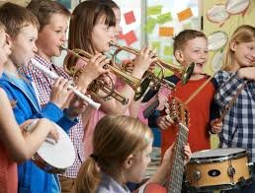

Famous People with High Musical Intelligence
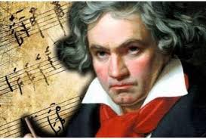
‘Music is a higher revelation than all wisdom and philosophy. Music is the electrical soil in which the spirit lives, thinks and invents’. Ludwig van Beethoven
Perhaps history’s greatest composer, Beethoven composed many of his best works after he had gone deaf. He said that he imagined the notes of all the many instruments in an orchestra in his head.
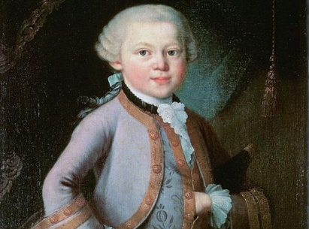
‘Writing music is my one and only passion and joy’. Wolfgang Amadeus Mozart
A true example of a child prodigy, the young composer showed incredible musical intelligence at a very early age. He could pick out tunes on the piano at the age of three, and began composing by age four. By the time he was 12, he had clocked up 10 symphonies and had performed for royalty.
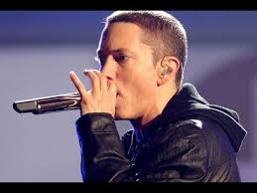
‘Hip-hop saved my life, man. It’s the only thing I’ve ever been even decent at. I don’t know how to do anything else’. Eminem

Contemporary rapper Eminem (Marshall Mathers) displayed extraordinary creative skills in his records and in such films as 8 mile. Renowned for his lyrical genius, he shows awareness of his own ‘smarts’ when he says: ‘I don’t think I’ve ever read poetry, ever. I’m not really book-smart.’
Imelda May
A native of The Liberties, Dublin, singer-songwriter and television presenter Imelda May attributes her world-wide success to her parents who instilled in her a love of music from an early age:
‘Both my parents were musical. My mum had been a seamstress and she wasn’t allowed to talk when she was working, but she was allowed to sing; she would sing all day long. My dad would play the harmonica. The record player was on the whole time and everyone liked different music, so there was a huge range of sounds: David Bowie, the Specials, Bing Crosby, the Carpenters, the Clash, Thin Lizzie, Ella Fitzgerald, the Undertones. I soaked everything up – I remember spending hours by that record player copying out lyrics over and over again.’
It seems logical, then, that the most important thing that we, as parents and teachers, can do to promote musical intelligence in children is to expose them to a wide variety of musical genres, and to demonstrate our own enthusiasm and passion for music. The availability of a wide range of music on such apps as Spotify and Apple Music, as well as youtube clips of countless musical performances and music lessons ensures access and exposure to a multitude of musical genres. How else can we cultivate ‘music smarts’?

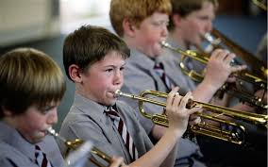
How to Awaken and Foster Musical Intelligence in Children
- Encourage them to join the school or community band and choir.
- Use music to develop the students’ skills and understanding within and across disciplines, e.g. learn to identify birds by their song.
- Include music in lessons, where possible, e.g. listening to music that was popular during various historical periods. (See attached timeline.)
- Buy books with rhythmic language, word pattern games and number games.
- Help them to create musical mnemonics and to use songs/rhythms when they need to learn something by rote.
- Help them to find rhythms and patterns in everything they see and learn.
- Have them write songs or repeat new concepts back to you in a musical tune of their choice.
- Encourage them to include music in independent projects and to study the lives of musically intelligent people throughout history.
- Encourage their ability to mimic other people's voices or intonation by assigning suitable roles in school and community plays and sketches.
- Put them in charge of sound effects or background music for school and community productions.
- Listen to a variety of soundscapes; naturally occurring melodies or rhythms in such phenomena as footsteps, birdsong and even in household appliances such as dishwashers and washing machines!
- Encourage them to regularly read and write poetry. (Fontaines DC frontman Grian Chatten recalls his Dad’s ploy of promising a new pack of football cards for every poem he could memorise as the motivation for learning the poems that he now references in the lyrics of his songs.)
- Provide forums for vocal and instrumental performance, in addition to Christmas and end-of-year concerts.
- Bring them to concerts, whenever possible.
- Provide opportunities for them to listen to audio recordings of poetry.
- Make instruments at home and at school. (see attached)
- Allow them to try out studying with instrumental music in the background (but not through headphones!) According to the University of Southern California, studies show that listening to classical music benefits the brain, sleep patterns, the immune system and stress levels in students.
This list is by no means exhaustive.
Career Ideas for People with High Musical Intelligence
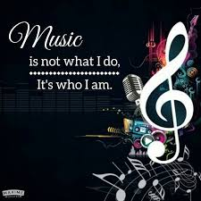
If musical intelligence is a strong point, potential career choices are:
- Musician
- Music critic
- Singer
- Composer (all genres)
- Music teacher
- Conductor
- Sound engineer
- Music producer
- Songwriter
It is important to note that the evidence to suggest one particular intelligence does not preclude others. Gardner, himself, has admitted that he is uncomfortable with the labelling of students as having one intelligence over another. Just because a child demonstrates visual-spatial intelligence, it doesn’t mean he or she can’t also possess naturalistic intelligence, for example. Albert Einstein once said:
If I were not a physicist, I would probably be a musician. I often think in music. I live my daydreams in music. I see my life in terms of music.
Music is a much more powerful learning tool than people tend to appreciate, and it is therefore important and beneficial for all of us to incorporate music into our daily lives. Even if musical intelligence isn’t exactly your forte, there are plenty of ways you develop it. Having children with strong musical intelligence in a class may mean that a teacher will intentionally increase music of all kinds in the classroom, and that will make for a pleasant classroom environment for all! As Confucius says: ‘Music produces a kind of pleasure which human nature cannot do without’.
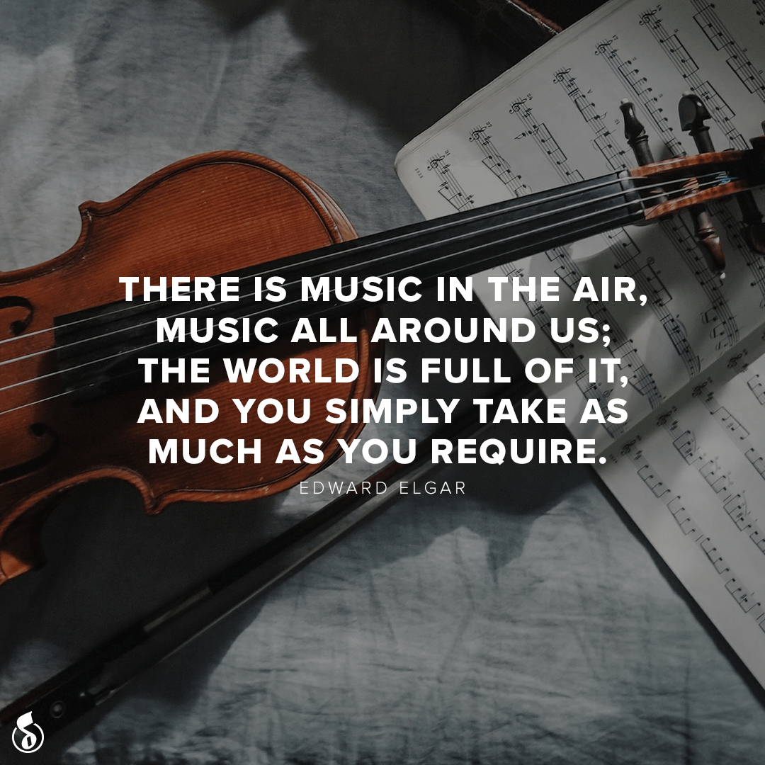

Helpful websites and resources
Musical Activities on Twinkl (Free to parents and teachers during Covid 19 school closure) Contains activities on: The History of Music, Musical Styles, Traditional Music from around the World, Music appreciation, instrument-making, music vocabulary, elements and notation etc.
https://www.google.ie/search?source=univ&tbm=isch&q=musical+activities+twinkl&hl=en-gb&client=safari&fir=zE1AqpJSDBYToM%253A%252CBbHva8hbMlMR0M%252C_%253BUp7LW-_969uc4M%253A%252Ce2tDVmbaCatWTM%252C_%253BYAvaDN1nKKhOyM%253A%252CEcCwxJQf4H3UZM%252C_%253Ble91tfvWbRd3mM%253A%252CLOQw1NGYbRahvM%252C_%253B-ytyKkskv358WM%253A%252CbcJHGBD6UnRpVM%252C_%253BeFWYfmH8E9GTBM%253A%252CamKn0zTWBCj8TM%252C_%253B0xUcG8gHsYK3iM%253A%252CNanr4KcTS34zJM%252C_%253B-5c-vNjNJ7k7XM%253A%252CbWZFmqPr6CViMM%252C_%253BNQCSr742NSUtvM%253A%252CE12O744jVtRERM%252C_%253BtGTysKyT2UkyDM%253A%252CcLOYCmInz_hEZM%252C_%257Cmusical%2520notation%253Bresources%253Bmusical%2520instruments%253Btreble%2520clef%253Blesson%2520plans%253Bpattern%253Bks1%253Bks2%253Bvirtual%2520piano%253Bnotes&usg=AI4_-kQS_1kzsUrfpZ_wYbzY2SxjNbTkQQ&sa=X&ved=2ahUKEwiQiO3mv9LpAhUDsXEKHT9iD4wQ420oCnoECAcQLA&biw=1024&bih=729
Best Music Apps for Kids. https://www.google.com/url?sa=i&url=https%3A%2F%2Fwww.educationalappstore.com%2Fbest-apps%2F5-best-music-apps-for-kids-to-play-and-listen&psig=AOvVaw0YoGV6giVBUE6Juas3D7XE&ust=1590668326338000&source=images&cd=vfe&ved=2ahUKEwifyNK1g9TpAhVHZ8AKHeoWAcIQr4kDegUIARD4AQ
Musical Genres timeline
https://www.softschools.com/timelines/music_genres_timeline/428/
At home with NCH (Lockdown Livestream Series, beginning May 29th)
https://www.nch.ie/Online/article/At-Home-With-NCH

Information on 2019 NCH Learning and Participation Programme (likely to run again in the future!)
https://www.nch.ie/Online/default.asp?BOparam::WScontent::loadArticle::permalink=Newsroom-LandP-Jan-Mar-19&BOparam::WScontent::loadArticle::context_id
Identifying Musical Instruments
https://www.twinkl.ie/resource/t-t-6994-musical-instrument-video-powerpoint
https://www.twinkl.ie/resource/musical-instruments-interactive-word-mat-activity-tg-38-newlink
Making Musical Instruments
https://www.twinkl.ie/resource/t2-par-25-musycling-musical-recycling-activity-pack
https://www.twinkl.ie/resource/make-a-musical-instrument-activity-t2-t-10000420
Listening To Music
https://www.twinkl.ie/resource/t-mu-18-the-carnival-of-the-animals-powerpoint
https://www.twinkl.ie/resource/ks1-traditional-music-around-the-world-powerpoint-english-t-mu-29
https://www.twinkl.ie/resource/roi-mu-1-traditional-tin-whistle-tunes-music-booklet
https://www.twinkl.ie/resource/t4-mu-15-popular-music-of-the-20th-and-21st-centuries-lesson-3
Film Music
https://www.twinkl.ie/resource/t4-mu-21-popular-music-of-the-20th-and-21st-centuries-lesson-8
Articles on Musical Intelligence
https://study.com/academy/lesson/musical-intelligence-definition-experiments-characteristics.html
https://www.thejakartapost.com/life/2019/06/03/think-your-child-has-musical-intelligence-heres-how-to-find-out.html
http://growingwithyourchild.com/the-musical-intelligence-how-to-identify-music-smart-learners/
https://www.quora.com/What-are-some-practical-signs-of-%E2%80%9Cmusical-intelligence%E2%80%9D-Besides-playing-an-instrument-or-sensitivity-to-pitch
Howard Gardner’s books on the Theory of Multiple Intelligences
Frames of Mind: Theory of Multiple Intelligences - Howard Gardner
Intelligence Reframed - Howard Gardner
Multiple Intelligences- Howard Gardner

