Tibetan groups urge China to free Panchen Lama after 25 years

Second most senior figure in Tibetan Buddhism was taken into custody when he was six
Fri, May 15, 2020, 22:30
Peter Goff in Chengdu
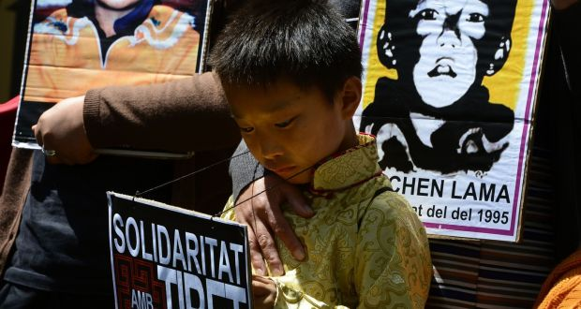
A pro-Tibetan vigil with pictures of Gedhun Choekyi Nyima outside the Chinese consulate in Barcelona, Spain. Groups have renewed calls on China to free the Tibetan identified as the Panchen Lama. Photograph: Getty Images

https://www.youtube.com/watch?v=jgQv1zDKZC0 Watch this too!

Share to FacebookShare to TwitterShare to Email App

On the 25th anniversary of the abduction of the six-year-old Panchen Lama there have been widespread calls from the international Tibetan community and rights groups for China to release him and his entire family.
Twenty-five years ago on Saturday the six-year-old Panchen Lama, the second most senior figure in Tibetan Buddhism, was taken into custody by Chinese officials. Gedhun Choekyi Nyima and his family have not been seen in public since, and rights groups have called him “the world’s youngest political prisoner”.
In 1995, the Chinese government rejected the Dalai Lama’s candidate as “illegal and invalid”, and six months after his abduction Beijing announced it had found “the real reincarnation”, Gyaltsen Norbu, the son of two Communist Party members from Tibet. Most Tibetans reject Beijing’s candidate, and refer to him as the “Panchen Zuma”, or the “false Panchen”.
A petition signed by leaders of 159 Tibetan and human rights organisations from 18 countries urged Michelle Bachelet, the UN High Commissioner for Human Rights, to take up the case with Beijing, saying “the 25 years of enforced disappearance [was] a crime against humanity”.
Beijing’s appointee, who lives in Beijing and is a member of the Communist Party’s top advisory body, the Chinese People’s Political Consultative Conference, has made only a few public appearances in Tibet.
China keeps the location of the now 31-year-old abducted Panchen Lama a tightly-guarded secret, with officials only saying he is “healthy, enjoying his education, and does not want to be disturbed”.
The Panchen Lama is one of the most important figures in Tibetan Buddhism, second only to the Dalai Lama (84), who has lived in exile since fleeing an aborted uprising in 1959. The Panchen Lama plays a key role in recognising the next reincarnation of the Dalai Lama, who then in turn leads the ritualistic search to identify the reincarnated Panchen Lama.
Beijing has said that when the current Dalai Lama dies the atheist Communist Party will control his succession and choose the next spiritual leader.

Foundations
The petition penned by the 159 organisations said China’s “meddling in the recognition of reincarnated lamas” was “destroying the foundations of Tibetan Buddhism”.
The 14th Dalai Lama has suggested he might appoint his own successor while he is still alive, possibly a girl for the first time, in an effort to stymie Beijing’s succession plans.
The US state department’s ambassador-at-large for international religious freedom, Sam Brownback, said Washington was also pressing Chinese authorities to release the Panchen Lama.
He said the issue took on an increased interest and importance as the Chinese Communist Party continued to assert its right to appoint the next Dalai Lama. “They don’t have the right to appoint the next Dalai Lama any more than they [have] the right to appoint the next pope.”

Questions
- How old was the Panchen Lama when he was abducted.
- What is the Panchen Lama?
- What have rights groups described the Panchen Lama as?
- How have the Chinese Authorities described him as being?
- From reading this article, and maybe further research you could do, what are your opinions on this matter? Upload your opinions to this question to SeeSaw please if possible.

