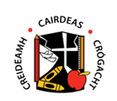

CALLING ALL STORYTELLERS
Short Story Competition
Calling all Edmondstown NS students to send in a creative writing piece based on the events that are happening in Ireland right now.
Express your thoughts on what has become your ‘New Reality’.
Categories broken into:
- Junior and Senior Infants
- First and Second Class
- Third and Fourth Class
- Fifth and Sixth class.
A winner will be chosen for each category!

Please send submissions to edmondstownns@hotmail.com

