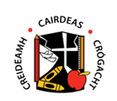

CALLING ON JUNIOR ARTISTS
Colouring Competition
Children from the junior classes may colour in one of the Easter Pictures and then send in a photo of it to the school email.

Categories broken into:
- Junior Infants
- Senior Infants
- First Class

A winner will be chosen for each category! Closing date: Friday, 17th April 2020

Please send submissions to edmondstownns@hotmail.com

