PAUSE TO PONDER

When life gives you lemons – make lemonade! Just like Pollyanna, we can always find something to be glad about in every situation. Why not start a gratitude jar and write down two things every day that you are glad about and grateful for.

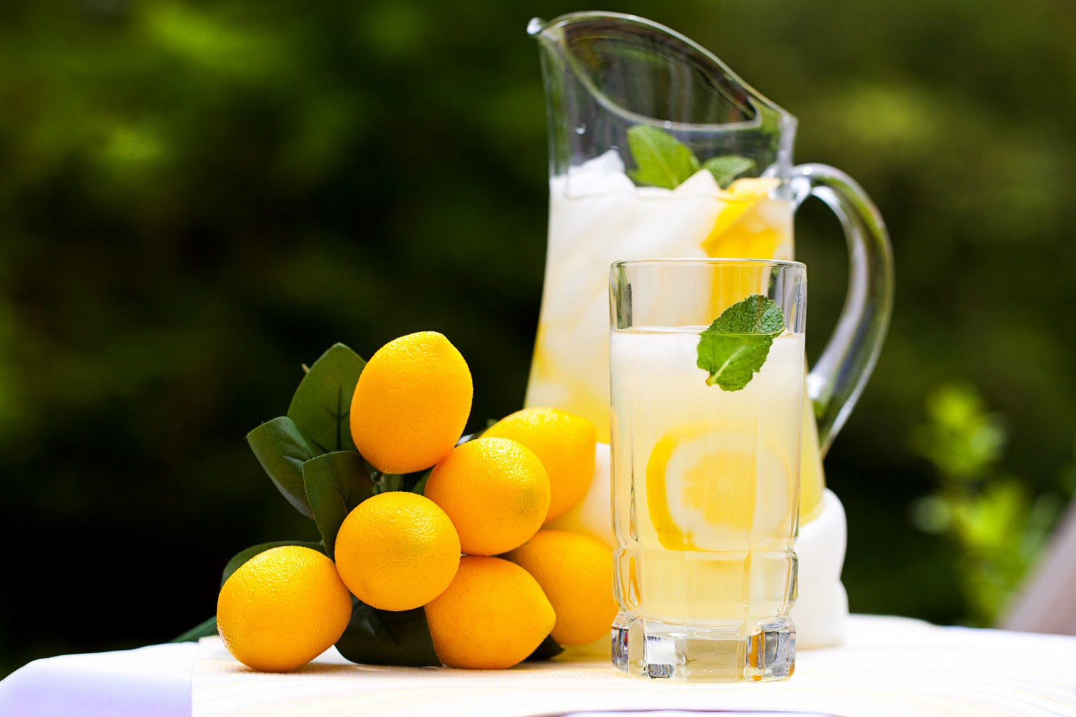

Philomena Cleary

