GAA Challenge
200 Touches Challenge
Suitable for Football or Hurling
- Find a suitable ball and wall, outside!
- Stand 3 steps back and time how long it takes you to complete the challenge.
- Video your attempt and see if your friends can beat your time.
- Increase difficulty by taking more steps back to start with.

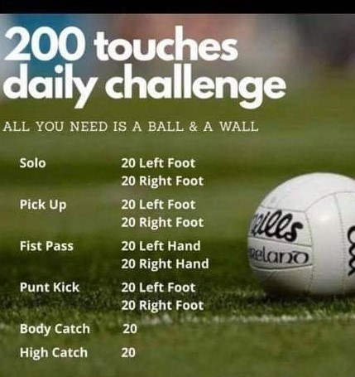

https://www.youtube.com/watch?v=edLyOIVABiE&t=27s

