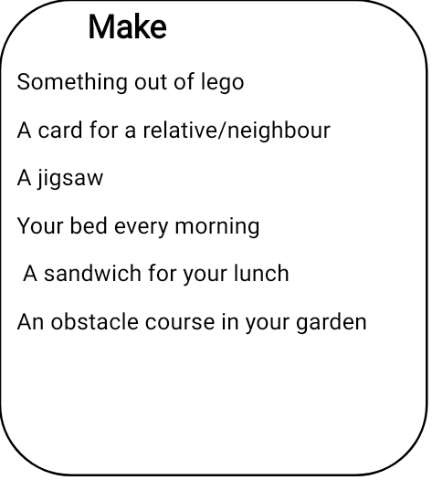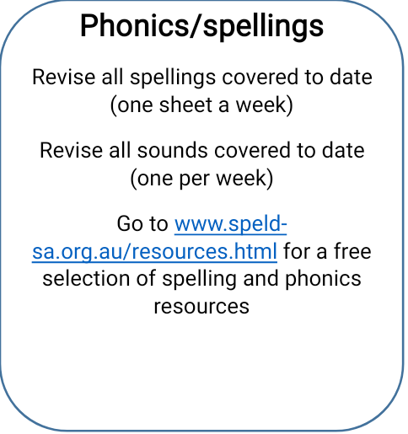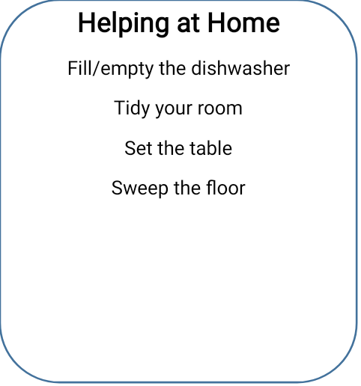

**Games/Exercise**

Joe Wicks for kids (youtube)

Go Noodle exercises (online)

Cosmic kids yoga (youtube)

Play a Board Game with your family [www.newhorizonholisticcentre.co.uk](http://www.newhorizonholisticcentre.co.uk) (for meditation/mindfulness)

A **Maths**

Practise your multip/division tables and telling the time using [www.topmarks.co.uk](http://www.topmarks.co.uk)

[www.fun4thebrain.com](http://www.fun4thebrain.com/) – (lovely addition and subtraction games)

[www.interactiveresources.co.uk](http://www.interactiveresources.co.uk) Lots of fun maths activities to do on www.interactiveresources.co.uk