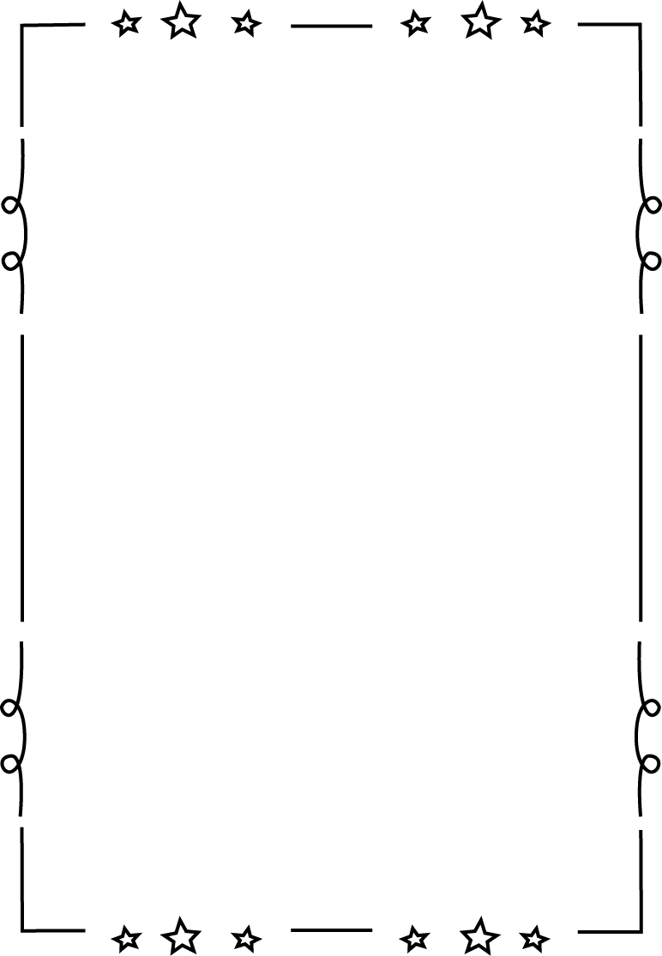

**Leabhar Gramadaí**

**- Rang a Sé**

Ainm: _________________

**Na téarmaí:**

|  |  |
| --- | --- |
| Briathar |  |
| Aidiacht |  |
| Guta |  |
| Consan |  |
| Fréamh |  |
| Caol |  |
| Leathan |  |
| Uatha |  |
| Iolra |  |
| Modh Ordaitheach |  |
| Aimsir Chaite |  |
| Aimsir Láithreach |  |
| Aimsir Fháistineach |  |
| Séimhiú |  |
| Urú |  |

**Bí Cúramach!**

LEATHAN le

LEATHAN

Aon focail a chríochnaíonn le a, o, u

= leathan ending

CAOL le CAOL

Aon focail a chríochnaíonn le i, e

= caol ending

**Modh Ordaitheach:**

Úsáidtear an modh ordaitheach den bhriathar nuair a bhíonn ordú á thabhairt.

*Mar shampla:*

Glan! Dún! Ceannaigh!

Glanaigí! Dúnaigi! Ceannaígí!

|  |  |
| --- | --- |
| Image result for stick manUatha | Image result for stick manImage result for stick manIolra |
| Suigh síos, a Sheáin | Suígí síos, a pháistí |
| Bí ciúin! | Bígí ciúin! |
| Téigh a chodladh | Téigí a chodladh |
| Ná bí dána! | Ná bígí dána! |
| Ná *h*ith é sin!  (cuir séimhiú roimh guta) | Ná *h*ithigí é sin!  (cuir séimhiú roimh guta) |

**An Aimsir Chaite:**

+ h

**Briathra rialto a**

**thosaíonn le consan**

+ D’

**Briathra a thosaíonn**

**le guta (a, e, I, o, u)**

+ D’_h

**Briathra a thosaíonn**

**le f**

Gan

athrú

**Briathra a thosaíonn**

**le l, n, r, st, sc, sr, sp**

**An Aimsir Láithreach:**

**+ ann**

**Leathan**

**(a, o, u)**

**Siolla**

**Amháin**

**+ eann**

**Caol**

**(i, e)**

**+ aíonn**

**aigh**

**Leathan**

**(a, o, u)**

**Dhá**

**Shiolla**

**+ íonn**

**igh**

**Caol**

**(I, e)**

**An Aimsir Fháistineach:**

**+ faidh**

**Leathan**

**(a, o, u)**

**Siolla**

**Amháin**

**+ fidh**

**Caol**

**(i, e)**

**+ óidh**

**aigh**

**Leathan**

**(a, o, u)**

**Dhá**

**Shiolla**

**+ eoidh**

**igh**

**Caol**

**(i, e)**

**Briathra Neamhrialta:**

|  |  |  |  |  |
| --- | --- | --- | --- | --- |
| Fréamh: | Béarla: | A.C | A.L | A.F |
| Abair | To say |  |  |  |
| Feic | To see |  |  |  |
| Faigh | To get |  |  |  |
| Téigh | To go |  |  |  |
| Bi | To be |  |  |  |
| Déan | To make/do |  |  |  |
| Beir | To grab |  |  |  |
| Clois | To hear |  |  |  |
| Ith | To eat |  |  |  |
| Tar | To come |  |  |  |
| Tabhair | To give |  |  |  |

**An Aidiacht Shealbhach 1:**

Mo t**h**each

Do t**h**each



[This Photo](http://en.wikipedia.org/wiki/User:Hybirdd) by Unknown Author is licensed under [CC BY-SA](https://creativecommons.org/licenses/by-sa/3.0/)

A t**h**each

A t**h**each

Ár **d**teach

Bhur **d**teach

A **d**teach

**An Aidiacht Shealbhach 2:**

**M’**athair

**D’**athair



[This Photo](http://en.wikipedia.org/wiki/User:Hybirdd) by Unknown Author is licensed under [CC BY-SA](https://creativecommons.org/licenses/by-sa/3.0/)

A athair

A **h**athair

Ár **n-**athair

Bhur **n-**athair

A **n-**athair

**An Aidiacht Shealbhach 3:**

**Conas a úsáideann tú urú?**

**(roimh na chonsan: b, c, d, f, g, p, t)**

**mb…**

**gc…**

**nd…**

**bhf…**

**ng…**

**bp…**

**dt…**

**N- roimh guta !**

**Réamhfhocail:**

mé (I)

tú (you)

sé/sí (he/she)

sinn (we)

sibh (ye)

siad (they)



[This Photo](http://bugaboominimrme.blogspot.com/2013/01/who-doesnt-love-good-ombre-monster.html) by Unknown Author is licensed under [CC BY-NC](https://creativecommons.org/licenses/by-nc/3.0/)



[This Photo](http://bugaboominimrme.blogspot.com/2013/01/who-doesnt-love-good-ombre-monster.html) by Unknown Author is licensed under [CC BY-NC](https://creativecommons.org/licenses/by-nc/3.0/)

|  |  |  |  |  |  |  |  |  |  |
| --- | --- | --- | --- | --- | --- | --- | --- | --- | --- |
|  | **le** | **ar** | **ag** | **do** | **as** | **ó** | **de** | **faoi** | **i** |
| mé |  |  |  |  |  |  |  |  |  |
| tú |  |  |  |  |  |  |  |  |  |
| sé |  |  |  |  |  |  |  |  |  |
| sí |  |  |  |  |  |  |  |  |  |
| sinn |  |  |  |  |  |  |  |  |  |
| sibh |  |  |  |  |  |  |  |  |  |
| siad |  |  |  |  |  |  |  |  |  |

**Na hUimhreacha Pearsanta:**

|  |  |
| --- | --- |
| Image result for stick man  1 | Image result for stick manImage result for stick man  2 |
| Image result for stick manImage result for stick manImage result for stick man  3 | Image result for stick manImage result for stick manImage result for stick manImage result for stick man  4 |
| Image result for stick manImage result for stick manImage result for stick manImage result for stick manImage result for stick man  5 | Image result for stick manImage result for stick manImage result for stick manImage result for stick manImage result for stick manImage result for stick man  6 |
| Image result for stick manImage result for stick manImage result for stick manImage result for stick manImage result for stick manImage result for stick manImage result for stick man  7 | Image result for stick manImage result for stick manImage result for stick manImage result for stick manImage result for stick manImage result for stick manImage result for stick manImage result for stick man  8 |
| Image result for stick manImage result for stick manImage result for stick manImage result for stick manImage result for stick manImage result for stick manImage result for stick manImage result for stick manImage result for stick man  9 | Image result for stick manImage result for stick manImage result for stick manImage result for stick manImage result for stick manImage result for stick manImage result for stick manImage result for stick manImage result for stick manImage result for stick man  10 |

**Bunuimhreacha 1-10:**

*(1-6 + séimhiú / 7-10 + urú)*

1. **Aon chapall amháin**



[This Photo](http://makeiriperu.blogspot.com/2015/) by Unknown Author is licensed under [CC BY-SA](https://creativecommons.org/licenses/by-sa/3.0/)

1. **Dhá chapall**
2. **Trí chapall**
3. **Ceithre chapall**



[This Photo](http://makeiriperu.blogspot.com/2015/05/unidad-3-propuestas-para-desarrolo.html) by Unknown Author is licensed under [CC BY-SA](https://creativecommons.org/licenses/by-sa/3.0/)

1. **Cúig chapall**
2. **Sé chapall**
3. **Seacht gcapall**



[This Photo](http://makeiriperu.blogspot.com/2015/05/unidad-3-propuestas-para-desarrolo.html) by Unknown Author is licensed under [CC BY-SA](https://creativecommons.org/licenses/by-sa/3.0/)

1. **Ocht gcapall**
2. **Naoi gcapall**



[This Photo](http://mondspeer.deviantart.com/art/halloween-smileys-the-mummy-489504076) by Unknown Author is licensed under [CC BY-SA-NC](https://creativecommons.org/licenses/by-nc-sa/3.0/)

**10)Deich gcapall**



[This Photo](http://makeiriperu.blogspot.com/2015/05/unidad-3-propuestas-para-desarrolo.html) by Unknown Author is licensed under [CC BY-SA](https://creativecommons.org/licenses/by-sa/3.0/)

**Urú for 17-19 depends on the vowel/consonant letter in the word!**

**Bunuimhreacha 11-20:**

* 1. *+ séimhiú / 17-19 + urú / 20 faic)*

**11) Aon chapall déag**

1. **Dhá chapall déag**
2. **Trí chapall déag**
3. **Ceithre chapall déág**
4. **Cúig chapall déag**
5. **Sé chapall déag**
6. **Seacht gcapall déag**
7. **Ocht gcapall déag**
8. **Naoi gcapall déag**

**10)Fiche capall**

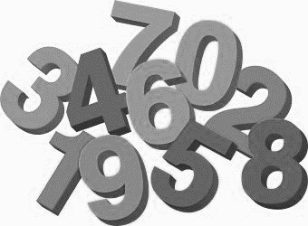

[This Photo](http://www.dailyclipart.net/clipart/category/math-clip-art/) by Unknown Author is licensed under [CC BY-ND](https://creativecommons.org/licenses/by-nd/3.0/)



[This Photo](http://makeiriperu.blogspot.com/2015/05/unidad-3-propuestas-para-desarrolo.html) by Unknown Author is licensed under [CC BY-SA](https://creativecommons.org/licenses/by-sa/3.0/)

**Urú for 17-19 depends on the vowel/consonant letter in the word!**

**Comparáidí:**

|  |  |  |
| --- | --- | --- |
| mór | níos mó | is mó |
| beag | **Níos lú** | **Is lú** |
| Óg | **Níos óige** | **Is óige** |
| Sean | **Níos sine** | **Is sine** |
| Ard | **Níos airde** | **Is airde** |
| Íseal | **Níos ísle** | **Is ísle** |
| Fada | **Níos faide** | **Is faide** |
| Soar | **Níos saoire** | **Is saoire** |
| Daor | **Níos daoire** | **Is daoire** |

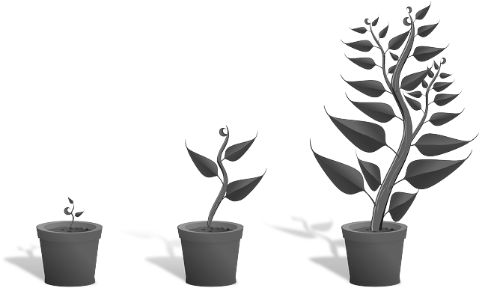

**Orduimhreacha:**

1st

3rd

**chéad**

**triú**

2nd

**dara**

5th

4th

**ceathrú**

**cúigiú**

6th

8th

7th

**séú**

**t-ochtú**

**seachtú**

10th

9th

**deichiú**

**naoú**

**Ceisteanna:**

|  |  |
| --- | --- |
| Cé? | *Who?* |
| Cén fáth? | *Why?* |
| Céard? | *What?* |
| Cathain? | *When?* |
| Cén t-ám? | *What time?* |
| Cá bhfuil? | *Where?* |
| Cad? | *What?* |
| Conas? | *How?* |
| Cén chaoi? | *How?* |
| Cé mhéad? | *How much/many?* |

**Laethanta na Seachtaine:**

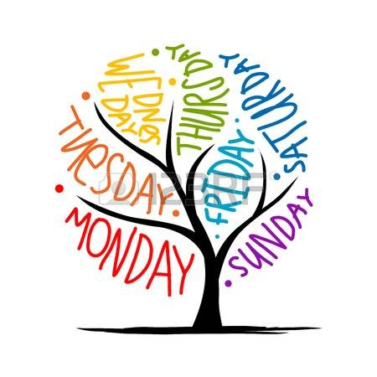An Luan

An Mháirt

An Chéadaoin

An Déardaoin

An Aoine

An Satharn

An Domhnach

Dé Lua**i**n

Dé Máirt

Dé Céadaoin

Déardaoin

De **h**Aoine

Dé Satha**i**rn

Dé Domhna**igh**

**(Today is Monday…) (On Monday…)**

|  |  |
| --- | --- |
| **An t-Earrach** | **An Samhraih:** |
| Feabhra  Related imageMárta  Aibreán | Bealtaine  Related imageMeitheamh  Iúil |
| **An Fomhar:** | **An Gheimreadh:** |
| Image result for autumn leaves clipart black and whiteLúnasa  Meán Fomhair  Deireadh Fomhair | Image result for snowflake clipartSamhain  Nollaig  Eanair |

**Na Míonna agus na Séasúir:**

**Nótaí breise:**



[This Photo](http://closeyourtextbooks.blogspot.com/2012_06_01_archive.html) by Unknown Author is licensed under [CC BY-NC-ND](https://creativecommons.org/licenses/by-nc-nd/3.0/)

____________________________________________________________________________________________________________________________________________________________________________________________________________________________________________________________________________________________________________________________________________________________________________________________________________________________________________________________________________________