‘Nature Smart’:
How To Identify And Foster Naturalistic Intelligence In Children

Up! up! my Friend, and quit your books;
Or surely you'll grow double:
Up! up! my Friend, and clear your looks;
Why all this toil and trouble? . . . .

Come forth into the light of things,
Let Nature be your teacher.

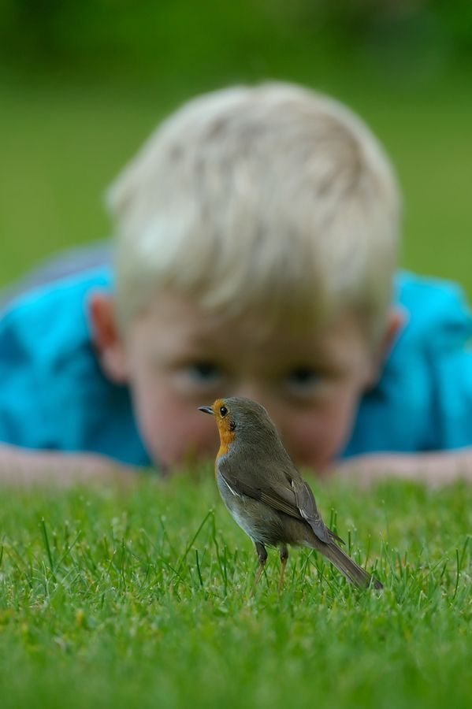

In his poem, The Tables Turned, William Wordsworth urges us to go outdoors and to learn from the greatest teacher of all – nature! As parents and teachers, we are aware of children who display a deep fascination with nature and are driven to investigate and become an expert in a particular natural subject. Children show that they are ‘nature smart’ when they have a keen awareness of the natural world and its phenomena. They demonstrate dramatic enthusiasm when in contact with nature and may appear to ’light up’ when discussing their particular area of interest. They often learn best when the content may be sorted and classified or is related to the natural world. Howard Gardner initially described seven types of human intelligence (see previous ‘How Smart Are You? How Are You Smart?’), in his ground-breaking book Frames of Mind: The Theory of Multiple Intelligences (1983). However, in 1994 he introduced his discovery of an eighth type of intelligence; ‘naturalistic intelligence’, which was officially added to his theory in Intelligence Reframed (1999).
Naturalistic intelligence is thought to be the type that aided our ancient hunter-gatherer ancestors in identifying which flora and fauna were edible and which were not. These ‘smarts’ may have increased the chances of survival of early humans, as they noticed subtle patterns and changes to their surrounding environment. Gardner notes ‘such persons with a high degree of naturalist intelligence are keenly aware of how to distinguish the diverse plants, animals, mountains or cloud configurations…’ This type of intelligence is present in the parts of the brain responsible for recognizing patterns, for making subtle connections, and is specific to those areas of the brain responsible for acute sensory perceptions, as well as object discrimination and classification. Most people with high naturalistic intelligence display an affinity with nature from an early age, but it is also possible to discover it later in life, or when one’s personal circumstances change, e.g. when a child from the city relocates to the countryside, or has access to a community garden or allotment, or when a child or adult takes up a new hobby.
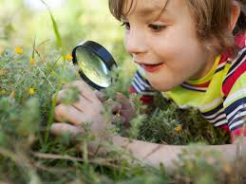
Children demonstrate naturalist intelligence when they:

- Enjoy being outdoors and feel most at ease when they are exploring the natural environment. They are interested in streams and rivers, oceans, mountains, forests, weather, rocks, bugs, animals, wetlands, lakes, deserts, and are ‘in their element’ when visiting these natural settings.
- Feel satisfaction in learning the names of flowers, trees, rocks, and minerals, dinosaurs, insects, birds, volcanoes, cloud formations, etc.
- Appreciate the natural world and its wonders, and seem inspired and renewed by interaction with nature.
- Love animals and seem to have a natural affinity with them. They nurture living things through gardening, or taking care of pets or bringing home stray animals. They may set up bird feeders or other feeding stations for animals.
- Feel strongly connected to the Earth – the planet and the soil! They may have ‘green fingers’ and love gardening or farming.
- Recognise patterns and colours and have keen observational skills. They patiently observe the activities of animals, birds and insects.
- Have a good understanding of the inter-connectedness of all living things, and follow cyclic pattern in nature such as the changing seasons, tides, moon phases, eclipses, and climate. They show a deep grasp of natural elements and can understand and explain natural phenomena.
- Collect and sort natural objects such as leaves, pebbles, feather or seashells and keep scrapbooks, photos, drawings, logs, or journals. They are very good at categorisation and have the ability to rank and classify animals, insects and things by attribute.
- Demonstrate a strong aversion to pollution – they are physically and emotionally adverse to environmental damage. They may have a heightened concern and awareness about endangered species and climate change.
- Enjoy recreational activities in the outdoors, such as hiking, rock-climbing, camping, sailing, snorkelling, scuba diving, cross-country skiing, etc.
- Enjoy watching nature programmes, documentaries, videos and reading books about nature.
- Like using equipment to find out more about the natural world, e.g. microscopes, telescopes, binoculars, magnifying glasses, butterfly nets, water-testing kits etc. They usually enjoy exploring and touching things from the natural world, including those others would perceive as ‘yucky’!
- Name zoos, farms, wildlife parks, aquariums, pet stores, riverbanks, etc. as their favourite places.
- Write about nature, seek music related to nature, and make crafts out of natural materials (e.g. seashells, leavess, pressed flowers, etc.)

Famous People With High Naturalistic Intelligence
Many of history’s most revered scientists and naturalists demonstrated high naturalistic intelligence from an early age.

Charles Darwin was ‘unsuccessful’ at school and was taken out of school two years early, but went on to become history’s most famous evolutionary scientist when he proposed the theory of evolution through natural selection. Darwin’s famous journey on the HMS Beagle allowed him to study and collect natural specimens from across the globe. He published his findings in ‘The Origin of the Species’.

Alexander von Humboldt was a 19th century naturalist and explorer, and was the first person to suggest that humans were having an impact on the natural world and causing climate change. His declaration was made over 200 years ago based on observations he recorded during his travels through South America.

E.O. Wilson, arguably the world’s greatest naturalist, the father of socio-biology, and author of ‘Ants’ (1990), one of two books for which he won the Pulitzer Prize, and in which he explained how these insects create social structures, organisations and hierarchies, traits that were once only attributable to humans.

John James Audoban: This naturalist created a collection of painting ‘Birds of America’ published in four volumes from 1827-1838. Audoban is considered to be the father of the conservationist movement and inspired millions to take to the woods, lakes and mountains in search of rare bird sightings.

Greta Thunberg, 17 year-old climate activist, has spoken about how nature documentaries were a huge inspiration to her. ‘That’s what made me decide to do something’, she said, when speaking to David Attenborough over Skype. Attenborough responded by saying that he was grateful to Thunberg for waking the world up, and ‘achieving something that many of us who’ve been working on it (climate) for years have failed to achieve’.

Environmentalist and author George Monbiot also made a video with Thunberg last year about the importance of natural climate solutions, such as peat bogs, mangroves, coral reefs and forests. It’s a positive, short video and is a good reminder of how our appreciation and care for the natural world is key to tackling the climate crisis. https://www.youtube.com/watch?v=-Q0xUXo2zEY

How To Awaken And Foster ‘Nature Smarts’

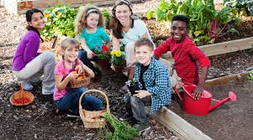

As parents and educators, we can enhance and strengthen naturalistic intelligence among young learners by providing opportunities for them to be inquisitive, to explore the world around them, to tune into the cycles of nature, and by encouraging them to:

- Attend lessons outside – take learning outside or near a window.
- Keep a nature journal to record and/or illustrate changes or discoveries in nature or outdoor learning.
- Take advantage of their ability to carefully observe, sort and make connections to the natural world in their general learning.
- Read books and articles about nature and the environment.
- Watch ‘nature’ television programmes and DVDs.
https://www.tvguide.com/news/best-nature-documentaries-watch-earth-day/
- Write poems, short stories and news articles about nature.
- Conduct research on local wildlife and vegetation in both rural and urban settings. As Alix Kates Shulman states: ‘Within walking distance of any spot on Earth there’s probably more than enough mystery to investigate in a lifetime.’
- Take informed action, in order to preserve the environment. Children, whose sensitivity to nature may result in anxiety about climate change, could write letters, petition their local politicians or work with others to clean up canals, beaches, river banks or communal green spaces. This may reduce feelings of powerlessness by channelling climate anxiety into positive action.
- Engage in conservation and recycling activities and projects.
- Encourage them to run for the Green Schools Committee in school, giving them an opportunity to take ownership of environmental issues and create a positive change in their local community.
- Present on their topic of interest to other children in school, in order to acknowledge their expert knowledge in a particular subject and to validate the benefit of sharing that expertise with others.

Nature Smart children experience learning best by relating, discovering, uncovering, observing, digging, planting, collecting, sorting, comparing and displaying. They will particularly enjoy:

Observing;
- Using all of their five (or six!) senses to experience nature: sight, hearing, smell, taste and touch!
- Watching animal behaviour squirrels or birds in the school yard, garden or local public amenity.
- Using a microscope, telescope, binoculars or magnifying glass.
- Weekly walkabouts to discern changes in the course of the school environment throughout the year.
- Keeping an eye on nests and dens.
- Watching the weather and learning to forecast weather.
- Noticing ecological principles in action, for example the decomposition of plant or animal material over time.

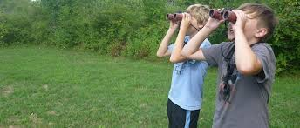
Recording observations;
- Keeping a nature journal, log, blog or diary.
- Imitating a botanist or ecologist doing field studies.
- Listing data about characteristics of natural things by size, colour, form, function and habitat.
- Drawing, sketching, photographing and videotaping natural phenomena.
- Modelling, measuring or drawing plants, animals and outdoor settings to scale.
- Documenting changes, stages, phases, metamorphoses and transformations in nature.

Classifying and categorising;
- Collecting things (literally ticking off a list) and identifying plants, leaves, berries, birds, feathers, nest, etc.
- Pointing out similarities and differences between species.
- Grouping, ranking, separating, adding up natural objects according to observed characteristics.
- Identifying sounds in the natural environment, e.g. Bird calls.

Working and learning in or with the natural world;
- Growing plants and vegetables in gardens in school, at home or in the community.
- Establishing nature trails, viewing platforms, bird tables, outdoor classrooms etc.
- Going on hikes and field trips.
- Performing role plays about animal behaviour, plant growth, etc.
- Reading stories or articles about the natural world, or in the fields of biology or ecology.

Career Ideas For People With High Naturalistic Intelligence
- Farmer
- Zookeeper
- Gardener
- Tree planter
- Park Ranger
- Veterinarian
- Geologist
- Landscape Architect
- Environmental planner
- Horticulturalist
- Conservationist
- Animal trainer
- Ecologist
- Botanist
- Archaeologist

Who knows? Perhaps, your resident ‘Little Green Fingers’ or ‘Dr Dolittle’ might one day join the long list of history’s most renowned natural scientists and change the world of science forever! Whether or not that comes to pass, it is now more important than ever before that we connect children to the living world, in order to avoid what Richard Louv, author of Last Child in the Woods, calls ‘Nature Deficit Disorder’. When we let Nature be our teacher, as William Wordsworth recommends, all children will become more attuned and connected to the world around them, and that is always to be welcomed.
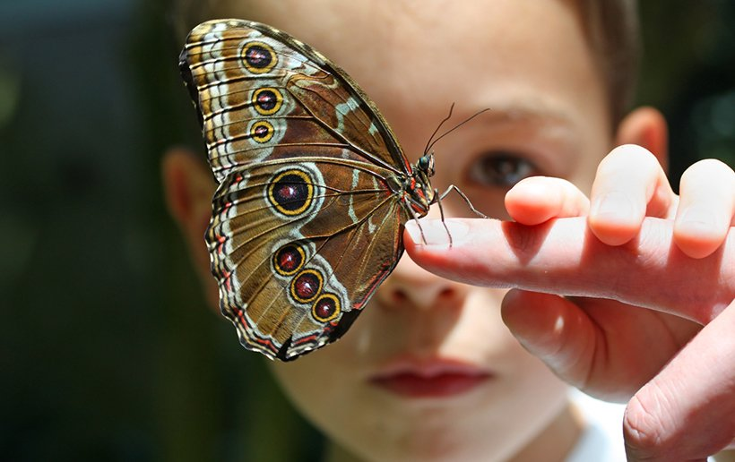
Useful Websites and Resources to Help Cultivate Nature Smarts

http://schoolearthed.ie/contact.html
Schoolearthed.ie (SEED – School Earth Education)
Educator, author and school garden expert Paddy Madden and educator Des Murtagh’s website schoolearthed.ie offers plenty of hands-on advice and nature-based projects for children to enjoy, from making their own snailery or scarecrow to creating a ‘dinosaur’ garden filled with leafy palms and giant tree ferns.

Use this chance to get to know the birds that come to almost every garden daily.
https://www.irishtimes.com/life-and-style/outdoors/garden-birds-to-see-and-hear-without-leaving-home-1.4223151

https://birdwatchireland.ie/

http://www.irishbirding.com/birds/web

Otters, kingfishers and dragonflies are just some of the creatures to be found along our rivers and canals. This article includes a storytelling competition Stories from the Waterside, open to all ages, closing date May 31, 2020.
https://www.irishtimes.com/life-and-style/travel/ireland/wildlife-on-the-waterways-a-guide-for-city-dwellers-1.4251526

Butterflies to Spot in Your Garden or nearby public space
https://www.irishtimes.com/life-and-style/outdoors/red-admiral-or-painted-lady-get-to-know-your-butterflies-1.4244034

Butterfly Ireland on what’s in flight right now:
https://butterflyconservation.ie/wp/

http://www.wildflowersofireland.net/
Wildflower expert and author Zoe Devlin’s book and website wildflowersofireland.net are brilliant resources for children and adults, right down to giving the name as Gaeilge of every species!

GIY.ie
https://giy.ie/
A great resource for helping people to grow their own food at home, at work, in school and in the community.
Getting Children into Gardening: grow runner beans, giant sunflowers and pumpkins
https://www.irishtimes.com/life-and-style/homes-and-property/gardens/want-to-get-children-into-gardening-you-could-start-with-sunflowers-and-a-snailery-1.4248334

https://www.irishtimes.com/life-and-style/homes-and-property/gardens/veg-out-may-is-the-perfect-time-to-sow-carrots-peas-beans-and-more-1.4244601

Growing herbs and salads on a balcony
https://www.irishtimes.com/life-and-style/homes-and-property/gardens/balcony-bounty-easy-grow-herbs-and-salads-that-thrive-in-small-spaces-1.4221916

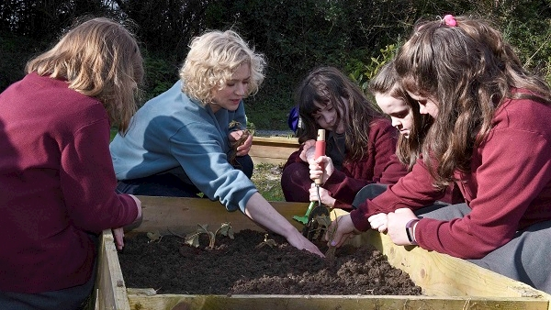
Read about the naturalistic intelligence of our very own Edmondstown National School pupils in the article below.
https://amp.irishexaminer.com/breakingnews/lifestyle/features/michelle-darmodys-food-mission-why-we-need-to-teach-our-kids-to-cook-at-school-997174.html

Watching the Clouds Go By!
https://www.irishtimes.com/life-and-style/outdoors/cloud-appreciation-the-pleasure-of-watching-the-sky-go-by-1.4234220

Using the natural world to help us through the Corona virus crisis:

Getting up-close with a beetle… and other calming distractions.
https://www.irishtimes.com/life-and-style/get-an-up-close-look-at-a-beetle-and-other-calming-distractions-1.4211053

8 Tips to Help You Garden Through the Crisis
https://www.irishtimes.com/life-and-style/homes-and-property/gardens/carry-on-gardening-eight-tips-to-help-you-garden-through-the-crisis-1.4233353

Growing Flowers for Summer – May, 2020
https://www.irishtimes.com/life-and-style/homes-and-property/gardens/from-cosmos-to-dizzy-dahlias-the-flowers-to-grow-now-for-summer-magic-1.4238853

Blogs
https://youngfermanaghnaturalist.wordpress.com/about/
Diary of a Young Naturalist – Book and blog by 16 year old Dara McAnulty

https://dghaskell.com/ramble-posts/
‘Ramble’ blogger David Haskell observed a square metre of forest floor over 12 months.

https://wildirelandtour.ie/
Delightful notes and observations from Liam Lysaght

How Trees Talk To Each Other, a TED talk by Suzanne Simard, who describes her fascination, as a child, with forests and how that led to her ground-breaking research into how trees communicate.
https://www.ted.com/talks/suzanne_simard_how_trees_talk_to_each_other?language=en

Virtual Tours
Use your online device as a window to the worlds from which we are currently excluded, if the natural world is beyond the allowed 5 km.

Dublin Zoo
https://www.dublinzoo.ie/event/virtual-tour/

Longleat.co.uk (safari tour narrated by Kate Humble)
https://www.longleat.co.uk/news/longleat-launches-virtual-safari

American Museum of Natural History (the Planetarium comes highly recommended)
https://www.googleadservices.com/pagead/aclk?sa=L&ai=DChcSEwjW5PCVm8XpAhVP7e0KHQZXCNUYABAAGgJkZw&ohost=www.google.com&cid=CAASEuRoyhas58hDbu9QmJJ9MZniaQ&sig=AOD64_2XLn3wo-Jv39GK9GEEHew3DzrckQ&q=&ved=2ahUKEwie9uiVm8XpAhXtTRUIHcSHBQoQ0Qx6BAgUEAE&adurl

The Natural History Museum of Ireland
https://www.museum.ie/Natural-History/Exhibitions/Current-Exhibitions/3D-Virtual-Visit-Natural-History

Climate Action and Sustainability
https://www.irishtimes.com/life-and-style/outdoors/david-attenborough-gives-humankind-one-last-chance-1.4236008

https://www.irishtimes.com/news/environment/greta-thunberg-calls-for-combined-action-on-coronavirus-and-climate-change-1.4235296

https://www.irishtimes.com/culture/books/how-to-make-your-life-more-sustainable-one-object-at-a-time-1.4225129
Ireland’s Public Awareness campaign on biodiversity:
https://www.irishtimes.com/life-and-style/outdoors/backyard-biodiversity-the-garden-guide-to-nature-1.4216819

Articles and books about Naturalistic Intelligence
https://www.greenhearted.org/naturalist-intelligence.html

https://www.outdoortopia.org/post/how-to-awaken-naturalistic-intelligence-in-children

https://www.thoughtco.com/naturalist-intelligence-8098

The Naturalist Intelligence: An Introduction to Gardner’s Eighth Intelligence by Karen Roth

Discovering the Naturalist Intelligence: Science in the School Yard (Jenna Glock, Susan Wertz and Maggie Meyer)

